

**COAL PROJECT PROPOSAL.**

**PROJECT NAME: LINE FOLLOWING ROBOT**

**GROUP MEMBERS:**

**EISHA MAZHAR 17K-3730**

**FATIMA IBRAHIM 17K-3639**

**MUHAMMAD ZAIN 16K-4070**

**OBJECTIVE:**

Line follower Robot is one of the first robots that beginners and students would get their first robotic experience with. In this project, we will design a simple Line Follower Robot using Arduino and some other components.

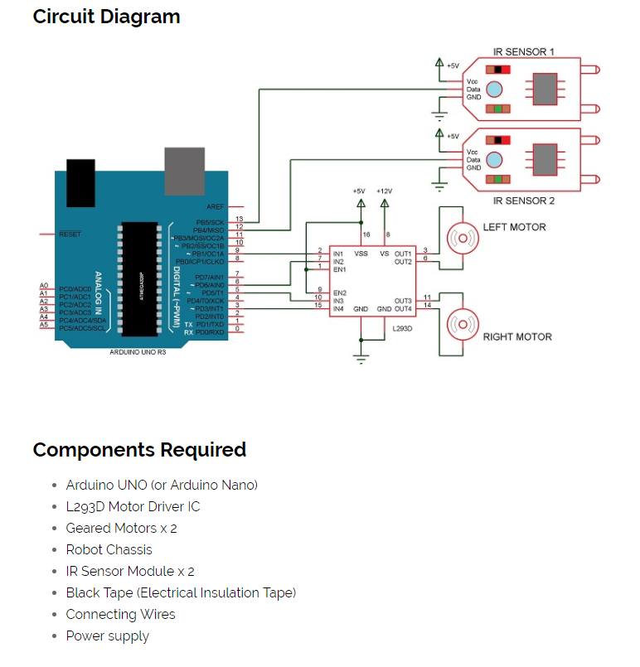

**DESCRIPTION:**We have to set up the hardware connections with the Arduino and the servo motors. The continuous rotation servo motors are those types of servo motors that cannot be controlled or set at a particular angle, unlike normal servos. Servos have three wires coming from them: Red=Power, Black=Ground, White/Yellow=PWM/PPM Signal. The left servo motor (white/yellow wire) is hooked up to Arduino digital pin 9 and the right servo motor (white/yellow wire) to Arduino digital pin 10. The black wires of both the motors are connected to Arduino GND and the red wires to the positive terminal of the battery holder.

**BLOCK DIAGRAM:**

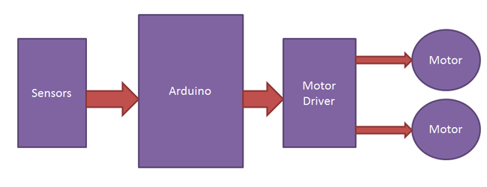

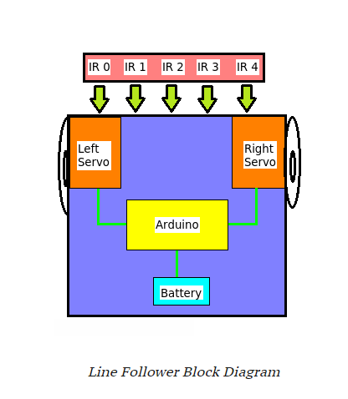

**APPLICATIONS:**

* Industrial automated equipment carriers.
* Automated cars.
* Tours guides in museums and other similar applications.
* Deliver the mail within the office building.
* Deliver medication in a hospital.

**ADVANTAGES:**

* Fit and forget.
* Insensitive to environment factors like noise and lightening.
* Capable of following a line which is specified to be followed.
* Capable of taking various degrees of turns.
* Cost effective.
* Long distance application .

**DISADVANTAGES:**

* It requires power supply.
* Lack of speed control makes it unstable.
* Choice of line is made in the hardware abstraction and cannot be changed by software.
* It moves on a fixed track.